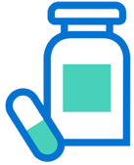
Getting the Most from Your New Medicine: NHS New Medicines Service
You have received this leaflet as your pharmacist has recently spoken with you regarding your newly prescribed medicines. Please use this leaflet for support, your local community pharmacist is always happy to support with any questions you may have.
Drug:
What is it used for?

How should I take it?

How does the drug work?

What can I expect when starting this medicine?

What are some common side effects?

Other important advice

If you have any questions


Your community pharmacist is here to help. If you have any questions or concerns about your new medicine, your local pharmacy is available to answer any questions:

