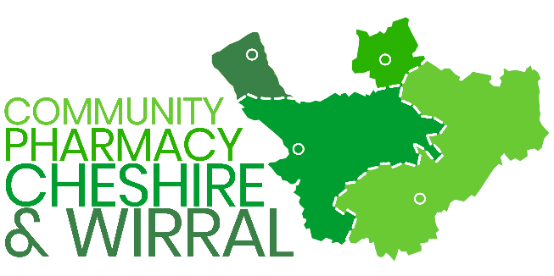 | NHS MAIL SUPPORT

To request a new NHS Mail account, please send an email from your organisation’s shared mailbox to helpdesk@nhs.net with the following user details:
- Full name
- UK registered mobile number
- Alternate email address
- Access required: User access/Owner access to the shared mailbox?
To access a shared mailbox, please follow these steps:
- Log in to your personal NHS Mail account via https://outlook.office.com
- Click on your profile name at the top right corner
- Select "Open another mailbox"
- Enter the name of the shared mailbox and click Open

For detailed guidance, please refer to the following official NHS support links:
- Shared Mailbox Guide
- Opening Shared Mailboxes
- Managing Shared Mailboxes
Once the required user details have been submitted from an authorised shared mailbox, NHS Mail will:
- Assign the request to the resolver team
- Create the new NHS Mail account
- Add the user to the shared mailbox
- Communicate the login details directly to the user

Please review NHS Mail’s policies on data retention and information management here:
https://support.nhs.net/knowledge-base/nhsmail-data-retention-and-information-management-policy/

If your organisation no longer has access to the shared mailbox, contact the National Administration Service by:
- Calling 0333 200 1133 from a site-registered phone number, OR
- Emailing from the DSPT-registered email address

You will be asked to verify your identity. Please provide:
- A statement that no one currently has access to the shared mailbox
- The new owner’s full name, UK mobile number (starting with ‘07’), and alternate email address
- If the new owner already has an NHS Mail account, include this information

Additional users can also be added at this time, or later by the new mailbox owner.

For more help, visit Unable to Access a Shared Mailbox – FAQs

