Pharmacy Contraception Service
The NHS pharmacy contraception service enables patients to attend their local pharmacy for initiation or onward supply of oral contraception.
What the service offers
• Continuation of oral contraception – Patients already taking the contraceptive pill can have their supply continued at the pharmacy.
• Initiation of oral contraception – Trained pharmacists can also start suitable patients on the contraceptive pill (following a structured consultation).
• The Service offers free and confidential access to emergency contraception to prevent unintended pregnancy after unprotected sex or contraceptive failure.
• Advice and support – Pharmacists provide information on safe and effective use, side effects, and wider sexual and reproductive health.
• Referral if needed – If there are concerns, or if another method of contraception is more appropriate, pharmacists can refer patients to their GP or local sexual health service.
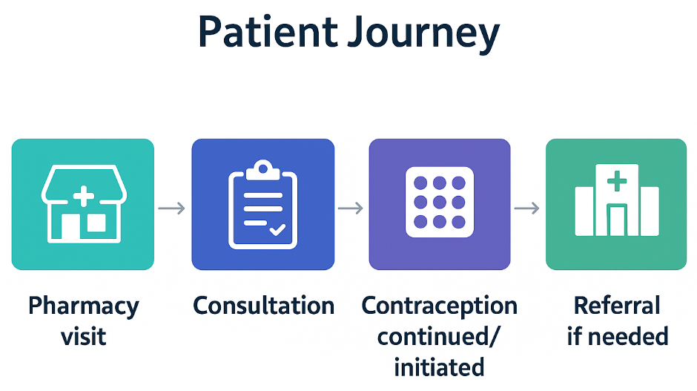

Who it is for
• Anyone seeking to continue or start oral contraception.
• Patients who value the convenience, accessibility, and privacy of community pharmacy.
• Anyone at risk of unintended pregnancy after unprotected sex or contraceptive failure, offering free, confidential, and timely access to emergency contraception.
Benefits
• Easier access to contraception through local pharmacies.
• Reduced pressure on GP appointments.
• Improved patient choice and access to expert advice in the community.
• Ensures free and consistent access to emergency contraception nationwide and enables national data collection to improve sexual health policy
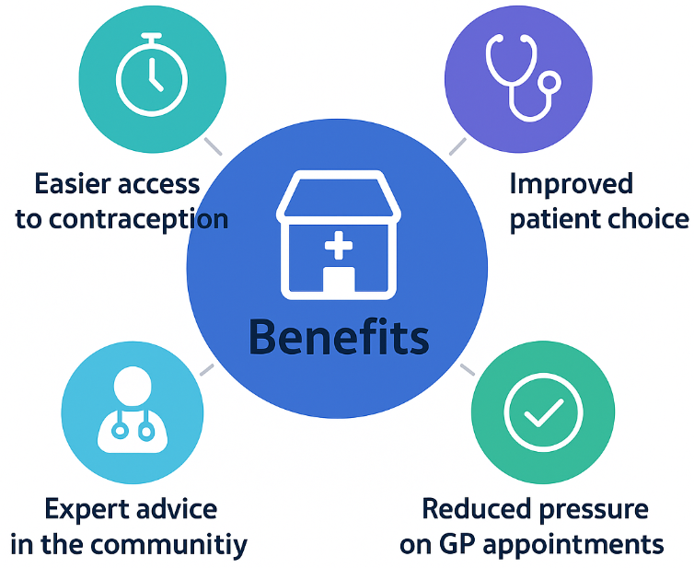
✅ Treatments available

• Combined Oral Contraceptive (COC) Pills
- Contain both estrogen and progestogen.
- Examples: Microgynon, Rigevidon, Marvelon, Yasmin, etc.
• Progestogen-Only Pills (POP, 'Mini-pill')
- Contain only progestogen.
- Examples: Desogestrel (Cerazette, Cerelle), Norethisterone-based POPs, etc.
• Emergency contraception (Emergency Hormonal Contraception, EHC).
-Examples: Levonorgestrel, Ulipristal Acetate.

❌ What’s not included
• Long-acting reversible contraception (LARC), e.g. implants, injections, IUD/IUS – these must be provided by sexual health clinics or GPs.
• Other hormone-based contraceptives (e.g. patch, ring).
📋 Key points
• Pharmacists provide a structured consultation to assess medical suitability using clinical checklists.
• They can both initiate and continue oral contraception supply.
• If a patient isn’t suitable for oral contraception, the pharmacist will signpost/referral to GP or sexual health services.
• Provides free, consistent, and confidential access to emergency contraception across the country, ensuring equity, clear clinical standards, and timely support for anyone at risk of unintended pregnancy.

