Smartcard Alert – What It Means for You
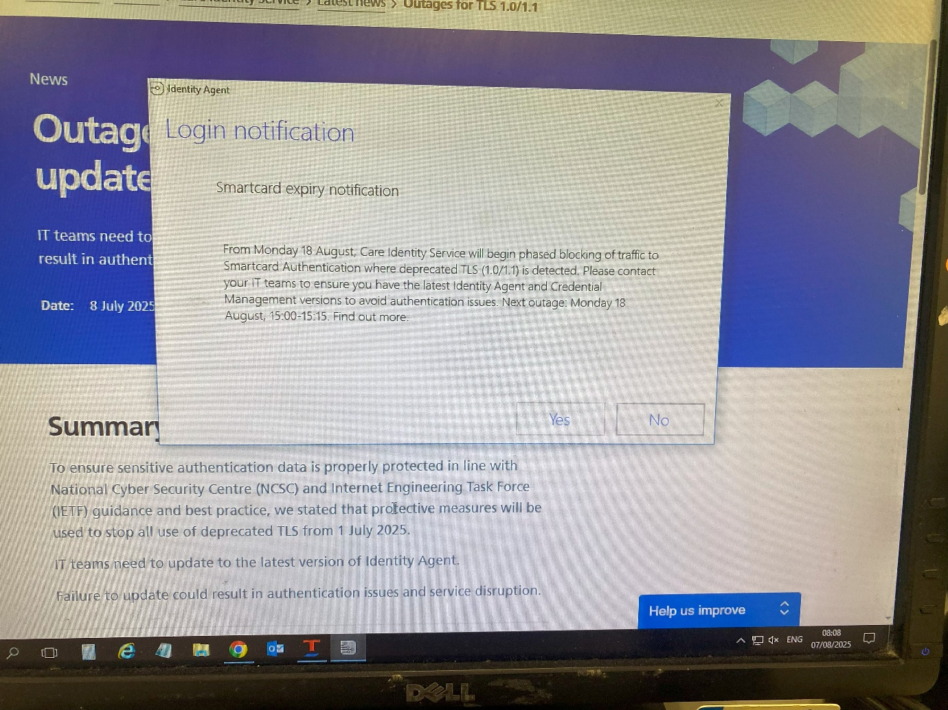
Some of you may have recently seen a Smartcard Alert notification and be unsure what action to take.
This alert is a reminder to ensure your system is fully up to date with the latest software.
If you are unsure whether your system is up to date, please contact your PMR (Patient Medication Record) system provider’s support team.
For example, if your PMR system is supplied by Proscript, you should contact the Proscript Helpdesk.
You can also check your system configuration by visiting:
Check whether a device is correctly configured - NHS England Digital
If you have any questions or need further support, please contact.
Sara@sefton-lpc.org.uk, Edward@sefton-lpc.org.uk

