Community Pharmacy Sefton LPC Minutes

Wednesday 3rd May 2023 at 2pm (via Zoom)
 | Name |  | Designation
Present | Dr Lisa Manning | LM | CEO
 | Sara Davies | SD | Pharmacy Services Lead
 | Joe Clarke | JC | Business Support Officer
 | James Moir | JM | Chair/Member/Aimp
 | Tracy McDonough | TM | Member/Ind
 | Martin Stratton | MS | Member/Ind
 | James Glover | JG | Member/AIMp
 | Una Harding | UH | Member/Ind
 | Victoria Jones | VJ | Member/CCA
 | Lucy Corner | LC | Member/CCA
 | Faye Orford | FO | Member/AIMp
 | Joanne Murphy | JMu | Member/CCA

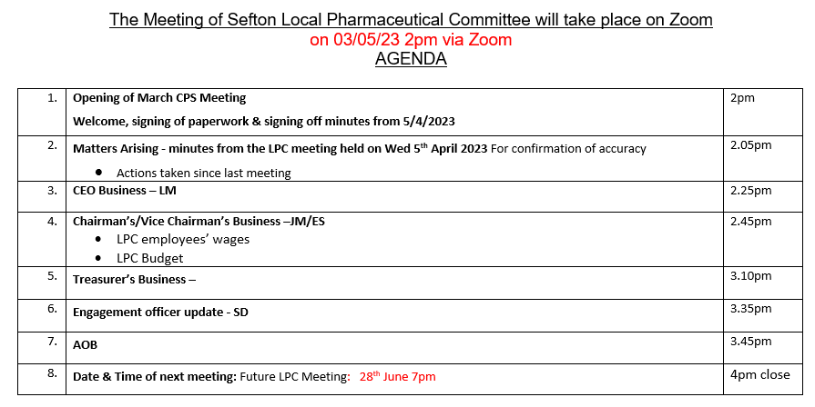

Members | April 23 | May 23 | Total
FO | X | / | 1/2 50%
JG | / | / | 2/2 100%
JM | / | / | 2/2 100%
JMU | X | / | 1/2 50%
LC | / | / | 2/2 100%
MS | / | / | 2/2 100%
TM | / | / | 2/2 100%
UH | / | / | 2/2 100%
VJ | / | / | 2/2 100%
Total | 7/9 | 9/9

1 | Welcome, Apologies for absence, Expressions of Interest | Action
1.1  1.2  1.3 | The meeting started promptly at 2pm. All members and officers were present. Fin McCaul joined the call at 2pm. Members were asked by JM to declare and expressions of Interest – no members declared any expressions. FO left the call at 14:40pm for personal reasons.  The previous minutes were signed off as a due and accurate record.  All Members welcomed themselves to our Guest, Fin McCaul from PSNC. Some members asked Fin some questions around the following:  - New Pharmacy Contraceptive Service  - 100-hour regulation changes  - Supervision  Fin answered all questions and members were pleased with the responses given. There were further discussions around price concessions, PQS and financial negotiations amongst Fin and the committee. Summary being that we have the ability to do more but we need more funding and new money doesn’t help with core services. Action point for JC to send two questions requested by Fin to LPC committee to answer subsequent to the next LPC meeting.  - What do we want from our regional rep?  - How do we see working more cohesively as a region? | Action – JC  Action - JC
2 | Matters Arising – minutes from the last LPC meeting
2.1  2.2  2.3  2.4  2.5  2.6 | The following actions were carried over to the next LPC meeting:  Sort 6-month levy holiday with NHSBSA  Send all Governance docs to JC by the end of April 2023  Meet to sort out the final numbers for 2023/24 LPC budget  Look at applying for a 15K outgoing restriction on LPC Bank Account  Discuss employment of Sue HR services and determine if Clyde &co provide sufficient resource  Pay review to be undertaken and the outcome shared with employees | Action – JC  Action – All  Action – JM/TM/JC  Action – JC  Action -All  Action -All
3 | CEO Business
3.1  3.2  3.3  3.4  3.5  3.6  3.7  3.8  3.9 | New Regulations – LM reminded members that all contractors will need a Business Continuity Plan in place for every contract. The deadline to have this in place by July 2023.  Minor Ailments Scheme Harmonisation – SLA has been sent. LM is working with other CEO’s regarding a response to the ICS but are waiting for next weeks’ Recovery Plan announcement.  EOI for Independent Pathway Finder – Closing date is 9th May. Members are asked to remind teams to send in EOI’s via Pharmoutcomes before the closing date otherwise there won’t be any further opportunities to join. MS shared that the Manchester EOI’s had strict stipulations around consultation rooms and asked if the Mersey version also had those stipulations. LM said that it didn’t. LM also shared that the three areas shared in the proposal were around:  - Providing a Minor Ailments linked to CPCS  - Respiratory (optional)  - SSRI Reviews (optional)  Pharmacy Contraceptive Service (PCS) – we have seven contractors within Sefton signed up to deliver this service. There is a webinar available for all contractors to view. Regional LPC’s have fedback concerns around lack of funding but are continuing to support contractors who have signed up and to help those contractors currently on the OCMS pilot migrate over to the PCS. SD has also shared comms with contractors.  Sefton Pharmacy Strategy – LM created the Sefton Pharmacy Strategy document and sent it to members for comments. UH thanked for her contribution. LM asked members to provide any further feedback to her asap. Members approved the document. JC to put on LPC website.  Smoking Cessation Services – LM send comms to members regarding the payment increase for NRT supply to £3 from £2.50. LM is still waiting for amendments to be made to the SLA and will share with members, once completed and ready. JC to add to the website once ready.  ICS Branded Generics List – This agenda item was brought up at the MALPS meeting. LM has contacted Sejal to get access to the ICS recommended list but to no avail. But LM received a response from the MMT stating they rejected most of the list and have shared the current QUIP work .JM gave some regional feedback from the recent MALPS meeting and suggested that LM share the outcome of a meeting with SL at the ICS. MS suggested that we take a zero-tolerance approach to this as an LPC. LM will keep trying to get hold of the list and to reiterate the effect on the patient, QUIP changes have been shared with contractors.  Sue HR – LM was given an action point at the last LPC meeting of contacting Sue to gain a price for a sessional fee. This fee was given as £140 per hour plus VAT. LM asked members if they had met to discuss the standing order for Sue HR. JM informed the meeting that the members had met before the LPC meeting today but didn’t have time to finalise both the Sue HR issue and the Officers pay review. JM will send out another zoom invitation for Wed 10th May 2023 and will give feedback on the findings to officers once this meeting has taken place.  LPC Dates – LM shared that she is on holiday for the July LPC meeting and proposed new dates and times for upcoming LPC meetings. After a brief discussion, it was decided to arrange an LPC meeting on the following dates & times:  - Wednesday 28th June at 7pm  - Wednesday 2nd August at 2pm  - Wednesday 27th September 7pm | Action – All  Action – JC  Action – LM  Action – JC  Action - LM  Action – JM  Action - JM
4 | Chairman’s Business
4.1  4.2 | We had another guest to today’s LPC meeting: Linda Lawson from Sefton Alzheimer’s Society. Linda spoke to members about the various free NHS services that are available throughout Sefton, including the numerous comms that she send out via social media, dementia advisors, singing groups, self-referral routes, befriending services, e-learning carers courses and paper copies of leaflets and magazines etc. Linda discussed ways in which community pharmacy can help start discussions with patients. Linda also shared details for the new Wellbeing Hubs that will offer practical help for people with blue badges, council tax grants etc. The hubs will be in Atkinson on 15th May and another at The Strand in Bootle. Linda shared that there were upcoming Pop-Up Cafes in Ainsdale. Linda shared that there are a number of events coming up for Dementia action week w/c 15th May 2023. These comms have been shared with LM.  JM to complete actions on discussing HR services and pay review of employees with the committee. JM raised about the NPA insurance and if it includes liability cover in the event of a HR issue claim. LM to share policy and JM to discuss with the NPA | Action JM  Action LM
5 | Treasurers Business
5.1  5.2 | TM shared the updated accounts information with members. Members had no further comments. LM informed the committee we are holding 169K, but this will come down with the 6 month levy holiday once in place, comms to be shared with contractors when applicable  JC shared the end of year accounts and proposed budget plans, based on last year’s accounts. MS brought up a query with the amount that we are paying the payroll company and asked questions about what we are paying for and for how much etc. JC was tasked with contacting the payroll company, asking for a breakdown of costs for their services. | Action - JC
6 | Engagement Officer update
6.1 | Sara Davies shared service data to PCN etc and informed the LPC on plans to deliver BP training to Ph Techs May-June in collaboration with other LPCs. She will also be supporting the OCMS pilot pharmacies migrate to the PCS service.
7 | AOB
7.1 | LC discussed the CCA quarterly report and completing it as a LPC when required. No objections from the committee and this was completed during the meeting.
8 | Date and time of next meeting
8.1 | The next LPC meeting will be Wednesday 28th June at 7pm

The meeting was brought to a close at 4:07pm (2 hours).

Action Log: Highlighted actions are carried over from previous meeting.
Min | Action | Person | Update
1.3 | Add minutes to the website | JC | Ongoing
2.1 | Sort 6-month levy holiday with NHSBSA | JC | Ongoing
2.2 | Send all Governance docs to JC by the end of April 2023 | All
2.3 | Meet to sort out the final numbers for 2023/24 LPC budget | JM/JC | Completed
2.4 | JC to look into new bank account and applying for a 15K outgoing restriction | JC
2.5 | JM to feedback outcome of meeting to determine Sure HR services | All/JM
2.6 | JM to feedback outcome of pay review | All/JM
1.3 | Email questions to committee via survey monkey/google form | JC | Completed
1.3 | Collate question responses and email to FinMcCaul on behalf of CP Sefton | JC | Completed
3.5 | Feedback comments to LM regarding the Sefton Pharmacy Strategy | All | Completed
3.5 | Add finalised Sefton Pharmacy Strategy to LPC website | JC | Completed
3.6 | Share final NRT supply SLA with members, once amendments have been made | LM
3.6 | Add NRT SLA to LPC website | JC | Completed
3.7 | Try to get hold of the Branded Generics List from Sejal Patel and share outcome of meeting with SL | LM
3.8 | Host Zoom meeting regarding staff pay review and Sue HR query | JM
3.8 | Feedback findings from Sue HR issue and staff pay review | JM
4.2 | LM to share NPA policy with JM. JM to contact NPA regarding the LPC requirements | LM/JM | LM completed
5.2 | Contact Payroll for a breakdown of fees and invoices | JC | Completed

