Community Pharmacy Sefton LPC Minutes

Wednesday 1st February 2023 at 7pm (via Zoom)
 | Name |  | Designation
Present | Dr Lisa Manning | LM | CEO
 | Emma Scanlan | ES | Vice Chair/Member/CCA
 | Sara Davies | SD | Engagement Officer
 | Janine O’Brien | JO | Member/CCA
 | James Glover | JG | Member/Aimp
 | Tracy McDonough | TM | Member/Ind
 | Martin Stratton | MSt | Member/Ind
 | Denise Hodge | DH | Member/CCA
 | Mehraan Sattar | MSa | Member/Independent
 | James Moir | JM | Chair/Member/Ind
 | Una Harding | UH | Member/Ind
Absent | Joe Clarke | JC | Business Support Officer

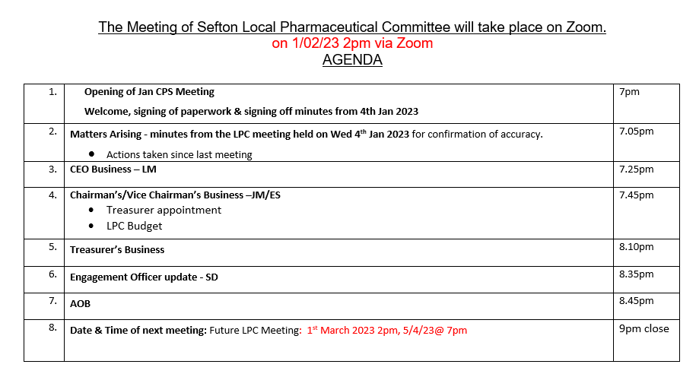

Members | Jan 23 | Feb 23 | Mar 23 | Apr 23 | May 22 | June 22 | July 22 | Sep 22 | Oct 22 | Nov 22 | Total
TM | / | x |  |  | / | / | X | / | / | / | 6/8 75%
JM | X | / |  |  | / | / | / | / | / | / | 7/8 88%
JO | / | / |  |  | / | X | / | / | / | X | 6/8 75%
UH | X | / |  |  | / | X | / | / | X | X | 4/8 50%
MSt | / | / |  |  | X | / | / | X | / | X | 5/8 63%
MSa | X | / |  |  | X | / | / | / | / | X | 5/8 63%
DH | / | / |  |  | X | / | / | / | X | / | 6/8 75%
ES | / | / |  |  | / | / | / | / | / | / | 8/8 100%
JG | / | / |  |  |  |  |  |  | X | / | 3/4 75%
Total | 6/9 | 9/9 |  |  | 6/9 | 7/9 | 8/9 | 8/9 | 6/9 | 5/9

Chair Signature: Date:

1 | Welcome, Apologies for absence, Expressions of Interest | Action
1.1 | ES opened the meeting due to JM’s late arrival. The meeting started at 7:13pm. The minutes were signed off as a due and accurate record and members had no other conflicts of interest. JC to add the previous minutes to the website. | Action - JC
2 | Matters Arising – minutes from the last LPC meeting
2.1  2.2  2.3  2.4  2.5  2.6  2.7 | JC to send out the SGM minutes to all contractors, as well as PSNC and Ian Cubbin.  JM met with JC to discuss potential extra hours for LPC Treasurer Role – Results of this was discussed during a closed meeting . It was confirmed that JC will discharge the admin requirements of the role and SD will take up the position of treasurer as an interim until April 2023, extra hours is to be raised at the March 2023 LPC meeting.  JC and LM have completed all the necessary processes regarding the changing over of the bank account from Santander to Lloyds and will update the committee at the next LPC meeting. Transfer is still ongoing.  SD is continuing to distribute the LPC Magazines to all contractors and should be completed by the next LPC meeting.  JM to feedback to officers’ details from September LPC meeting, LM spoke with Sue from HR but so far JM has yet to speak to both SD and JC regarding outcome of the September LPC meeting and Sue from HR has yet to contact both SD and JC. Sue will take notes from the April appraisals of JC and SD.  ES to contact comms lead from other LPCs (Stuart Radley/Dane Stratton Powell) regards comms linking up. ES has sent a message David Barker from HSHK LPC and Liverpool LPC. LM suggested that ES look at the PSNC website for comms on MP lobbying etc for more information.  Finance Subgroup still haven’t met to discuss the budget for 2023/24 Appointment of treasurer from April 2023. | Action – JC  Action – JM  Action – SD  Action -JM  Action - ES  Action - Finance Subgroup
3 | CEO Business
3.1  3.2  3.3  3.4  3.5  3.6  3.7  3.8  3.9  3.10  3.11  3.12  3.13  3.14  3.15  3.16  3.17 | Reminder to complete the pharmacy pressures survey on PharmOutcomes so that PSNC can have a clearer picture of the current pressures and use as evidence to lobby government. LM shared that Community Pharmacy Sefton have liaised with local MP’s and the APPG regarding the pressures on community pharmacy too and LM has shared all comms with members. Had full MP support.  National Contraceptive Service – LM shared that there is a delay with this service from 13th January, to likely be early spring. PSNC withholding starting due to the IT issues. All comms will be sent out accordingly. The service spec is out for contractors to read in the meantime. The pilot sites are still running up to the end of March 2023, with more coming on to Tier 2.  NMS – voluntary data collection with this service, not mandatory within contract but data can help support services will be collected.  LPC training for Members – Members Days will be coming at the end of February. LM has previously sent JG information regarding LPC Member Day.  Winter Vaccine Leaflet Drop – LM has arranged for this to be in place and arranged for payments. Two contractors had responded so further comms went out. Those commissioned have been contacted via Fran Walker.  CPAF – Final date was 5th February. LM and SD supported the one contractor that hadn’t completed.  Minor Ailment Scheme – LM has shared all relevant information regarding the harmonization of this scheme. The PGD’s are still in development and some areas are still being smoothed out egr Sore Throats potential (Tier 3) etc. LM encouraged members to look at the PGD’s. and MAS comms she sent.  Formby Rota – LM shared that a member requested to pull out from the Formby Rota (to open on Sunday’s and Bank Holiday’s). LM is liaising with NHSE to discuss possible outcomes.  API IT Issues – LM shared that there is a queue system with the API IT issues and that the following services will be switched on in this order – Contraception, DMS, Blood Pressure. Concerns have been raised about this order (with DMS not being prioritized) but this is ongoing. JO shared that she had spoken with Kevin Noble and he suggested that they were waiting on BSA to get on board.  Continuous Glucose Meters – LM spoke to members regarding the Glucose Meters and the current issues around re-ordering transmitters and lack of funding etc. This was raised at LMC and PSNC have requested this to go into the drug tariff within the coming weeks.  Change of Ownership – LM has had notification of a change of ownership and will update members as and when the necessary communications arrive.  Store Closures – Lloyds have sent out comms regarding the store closures of the tone store within Sefton, on 23rd April 2023. The other store is a change of ownership.  IP Pathfinder – LM had a meeting this week with the regional/national team and there was a webinar last night (31st Jan) for all contractors. This involves the ICS to send in an EOI for funding of IP sessions within community pharmacy service links up with PCN’s and could see referrals to CP IPs for various services such as respiratory, BP, minor ailments etc. The contractor running the sessions will be paid, whether patients turn up or not. The IPs must be already trained. The contractor will receive a fee for housing these sessions. The concerns around fees have been raised. LM to ask MMT/LMC/PCNs if they have details of any GPs or equivalent who would be willing to be a DDP for CP  Independent Prescriber Survey – Matt Harvey has sent out a survey via PharmOutcomes to establish which contractors are Independent Prescribers so that we can feedback this information to the NHSE team.  Public Health Campaigns – Despite the recent PH Campaign, there was no request for reporting for any participation for this campaign.  MALPS – JM is attending on behalf of Community Pharmacy Sefton. ES is also in attendance and has received the invitation from Alison Williams.  Palliative Care Survey – LM has sent out all comms regarding the 16 Palliative Care meds with contractors. This information will not be shared on the LPC website after direction from the PSNC. But will help contractors meet their PQS domain requirements.
4 | Chairman’s Business
4.1 | JM spoke with Sue from HR company who said that officers who continually accrue extra hours were legally entitled to extra holiday pay. JM asked members if they had any objections to paying this entitlement. Members had no further objections and JM will liaise with Sue from HR on this.
5 | Treasurers Business
5.1 | We currently don’t have a treasurer, so no update was given. - UH to ask our current auditors re the role – Update they confirmed they would not undertake this role  We currently have 152k in the account. The PSNC levy for 2022/23 has been paid in full. JM has requested budget template from Laura Benyon
6 | Engagement Officer update
6.1 | SD shared that she has been out delivering comms from Community Pharmacy Sefton (magazine/posters). SD shared that whilst she is in practices and pharmacies, she is chasing up on the following services:  - Hypertension Case Finding.  JG enquired an updated on the GP Emails being signed up to Pinnacle. SD is in contact with Idris from EMIS regarding this and will update members accordingly.  LM said that she has raised all concerns regarding the using the hypertension service Emis Button instead of a verbal referral with MMT and LMC. SD asked members if we could create an aide memoir for GP’s regarding the Blood Pressure Services. After discussion, it was decided to go ahead to create these posters and get them printed and delivered. UH explained about the DES and BP target, LM explained about the proposed SS PCN BP project. LM explained has requested comms regarding BP service to be in the GP Bulletin.  - SD continuing to push service Oral Contraception Management Service (all tiers), including preparation for going national. | Action - SD
7 | AOB
7.1  7.2  7.3 | PNA – JO asked if we had enough coverage for the Sefton PNA now that Lloyd’s stores were closing. Members discussed and concluded that there is enough coverage.  LPC committee – LM confirmed that numbers for the LPC committee will not change (with the Lloyd’s store closures) as we go off what contractors we had as of 31st October 2022.  Meds Management Meeting – JG invited to attend this meeting on 27th February 2023 at 2pm. JG to attend with LM and SD. | Action - JG
8 | Date and time of next meeting
8.1 | The next LPC meeting will be Wednesday 1st March 2023 @2pm via zoom

The meeting was brought to a close at 8:19pm (1.5 hours).

Action Log: Highlighted actions are carried over from previous meeting

Min | Action | Person | Update
1.1 | Add minutes to the website | JC | Ongoing
 | Explore the possibility of a mental health service via a PCN – JO to send through Lloyds mental health campaign documents for consideration if and when any become available | JO | Ongoing
2.2 | Speak to JC regarding potential extra hours for LPC Treasurer Role as an agenda item for March LPC Meeting | JM
2.3 | SD to distribute magazines and meeting with ES to handover comms materials | SD/ES
2.5 | JM to feedback to officers’ details from September LPC meeting, JM to provide contact details of HR person and set up an initial contact meeting | JM
2.6 | ES to Speak with other comms leads from other LPC’s (Dane Stratton Smith/Stuart Dudley) | ES
2.6 | Create budget for 22/23 / Appoint treasurer from April 2023 | Finance subgroup
2.1 | Send out the minutes of the SGM to all contractors and PSNC/Ian Cubbin | JC
3.13 | LM to ask about DDPs across Sefton | LM
6.1 | Create GP Posters for Blood Pressure Services to print and distribute | SD
7.3 | Attend upcoming Meds Management Meeting on 27th Feb at 2pm | JG

