Community Pharmacy Sefton LPC Minutes
Wednesday 16th November 2022

@ 7pm
 | Name |  | Designation
Present | Dr Lisa Manning | LM | CEO
 | James Moir | JM | Chair/Member/Ind
 | Emma Scanlan | ES | Vice Chair/Member/CCA
 | Sara Davies | SD | Engagement Officer
 | Denise Hodge | DH | Member/CCA
 | James Glover | JG | Member/Aimp
 | Tracy McDonough | TM | Member/Ind
Absent | Mehraan Sattar | MSa | Member/Independent
 | Janine O’Brien | JO | Member/CCA
 | Martin Stratton | MSt | Member/Ind
 | Joe Clarke | JC | Business Support Officer
 | Una Harding | UH | Member/Ind

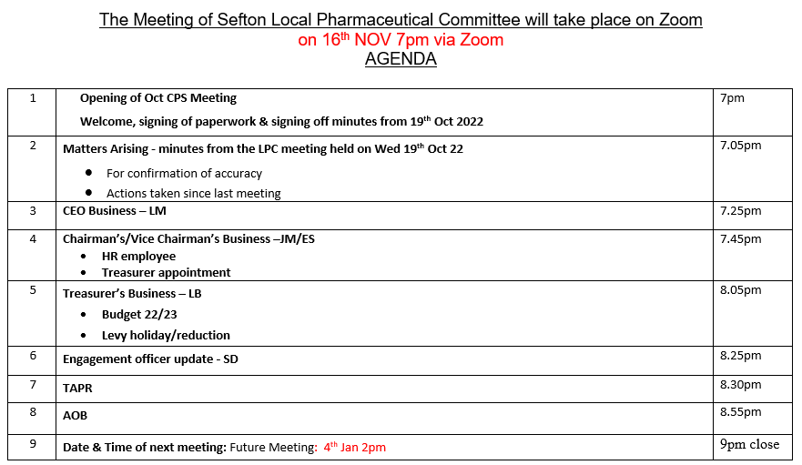

Members | Jan | Feb | Mar | April | May | June | July | Sept | Oct | Nov | Dec | Attend
TM | / | / | / | LPC Meeting Cancelled | / | / | X | / | / | / |  | 8/9 88%
JM | / | / | / |  | / | / | / | / | / | / |  | 9/9 100%
JO | X | / | / |  | / | X | / | / | / | X |  | 6/9 66%
UH | X | / | X |  | / | X | / | / | X | X |  | 4/9 44%
MSt | / | / | / |  | X | / | / | X | / | X |  | 6/9 66%
LB | / | / | / |  | / | / | / | / |  |  |  | 7/7 100%
MSa | / | / | / |  | X | / | / | / | / | X |  | 7/9 77%
DH | / | / | / |  | X | / | / | / | X | / |  | 7/9 77%
ES | / | / | X |  | / | / | / | / | / | / |  | 7/9 77%
JG |  |  |  |  |  |  |  |  | X | / |  | 1/2 50%
Total | 8/9 | 9/9 | 7/9 |  | 6/9 | 7/9 | 8/9 | 8/9 | 6/9 | 5/9
*LB left the LPC after the September 22 meeting
*JG Joined the LPC for the October 22 meeting

Chair Signature: Date:

1 | Welcome, Apologies for absence, Expressions of Interest | Action
1.1 | LM welcomed members to the meeting. LM welcomed James Glover (JG) to the meeting and all members and officers introduced themselves to him. JG also welcomed himself to the committee, explaining his work history and shared that he was on the committee to replace LB as AIMp representative. LM previously sent JG all the necessary Governance forms and reminded him to get them to JC as soon as he can.  The minutes were signed off as a due and accurate record and members had no other conflicts of interest. JC to add the previous minutes to the website. | Action - JG  Action - JC
2 | Matters Arising – minutes from the last LPC meeting
2.1  2.2  2.3  2.4  2.5  2.6  2.7  2.8 | Finance Subgroup – The finance subgroup hasn’t yet met since the last LPC meeting. LM shared that her pharmacy phone is no longer working and that she will need to buy a new handset and submit an invoice to the committee. JM asked members if they had any objections, members had no objections so LM to follow that process. Subgroup to continue to discuss the PSNC levy for 2023/24.  Treasurer’s Role – JM/ES are still to speak to JC regarding this role. SD said that she knew someone (an accountant) that may be interested, and JM shared that MSt also had someone in mind. JM to contact JC to talk about extra hours and role etc.  LPC Bank Account – LM shared that she has spoken with Santander regarding the online banking query and shared that Santander no longer offer the service that we wish to use. JM asked members if they had any problems with JC speaking to other banks in order to get this process completed. Members had no objections. JC to speak with other banks regarding the type of online account that we need.  LPC Magazine – JC picked up the magazines from the printers today. JC and SD to liaise about the best way of getting the magazines and posters out to contractors and GP’s.  HR – JM to speak to SD and JC regarding the HR issues that were brought up in the September meeting. JM and SD arranged a meeting on the call. JM to speak with JC regarding availability for this meeting. The roles and responsibilities document hasn’t yet been completed due to the non-payment for Sue, which has now been set up.  DMS Issue – JC has contacted Bruce Prentice regarding the DMS issue and hasn’t yet had a response. JC to chase with Bruce via telephone call.  Services Subgroup – The subgroup were due to meet to discuss PQS, contraceptive pilots and maximising services in Sefton but this action is to be carried over as JO has been in hospital.  Levy Holiday/Budget – The finance subgroup were due to meet to create a budget for 22/23 and discuss levy holiday. This action is ongoing. | Action LM  Action – Finance SG  Action – JM  Action – JC  Action – JC/SD  Action – JM  Action – JC  Action – Services Subgroup
3 | CEO Business
3.1  3.2  3.3  3.4  3.5  3.6  3.7  3.8  3.9  3.10 | CPPE – LM has been in contact with CPPE who said that superintendents can see the status of PQS without asking where people are up to. This includes dispensers etc. LM previously shared this information with all contractors via her weekly update.  COVID Clinics – A reminder to claim within 14 days (from the end of the month), otherwise you won’t be paid for the work.  PQS – LM continually sends out weekly briefings and updates that focuses on locality. LM shared a breakdown of the work that she is doing around PQS and asked members to complete the Palliative Care survey as soon as possible. LM to send this out soon.  Inhaler Project – LM thanks members for their comments and shared that the draft SLA has been sent out. Matt Harvey is collating the comments and LM will continue to liaise with Matt and the committee regarding this service.  MALPS meeting – The is a meeting on 7th December. LM, JM, ES and JG will be in attendance to discuss the TAPR/RSG proposals.  HEE Workforce Survey – The deadline is 30th November, and we still have some outstanding contractors who haven’t completed. JC and SD were continuing to support with this.  EHC Invoices – LM explained that there was a slight PharmOutcomes issue regarding an outstanding payment from 2021 but that LM was continuing to liaise with Lynne Hindle regarding the payment delays.  Visions – LM thanked members for their responses and asked if they were happy for LM to complete on behalf of the LPC before the deadline in December.  Blood Pressure Pilot – LM shared that there was going to be a small pilot in South Sefton PCN. JG asked if the issues with Blood Pressure results and PharmOutcomes can be rectified soon as it was a waste of time having to print off paper copies and manually having to input them. LM shared that this has been flagged and is in hand.  ICS priorities – Pam Soo has moved across from NHSE and is linking up with Peter Johnson. There are two priorities going forward: harmonization around minor ailments schemes (which might be widened across the North-West and DDA NDS issue and utilizing that tool across Merseyside. | Action - All
4 | Chairman’s Business
4.1 | JM shared that the PSNC have changed the transitional payments from December 2022 and for members to be aware of this, which has more of a focus on services. This pay mean an increase or a reduction in transitional payments, depending on location. PSNC sent an email out and LM has shared further comms on this.  JM has been invited by PSNC regarding TAPR programme and will share details once confirmed.
5 | Treasurers Business
5.1 | We currently do not have a treasurer in place and no further updates were given by JM other than those already given in tonight’s meeting.
6 | Engagement Officer update
6.1 | SD shared that we have seen a drop in GP CPCS referrals from GP practices. SD is looking at developing a leaflet to aid this service. Members asked if there was a drop in referrals because Pharmacy were not holding up there end of the bargain. LM and SD shared that this was certainly the issue at a tiny number of contractors but that most of the issues centre around the turnover of GP Practice staff and the fact that a lot of new staff aren’t trained. SD and JC will continue to push for training. TM shared that she has a pilot going on over in Yorkshire regarding a walk-in self-referral service and will send over the details of this to the committee. | Action - TM
7 | TAPR Proposals
7.1 | LM shared the options appraisal template with members and filled in her thinking for each section of the spreadsheet. LM asked members for their options and reasoning behind each score and context behind it. LM completed the document live as members were discussing each option and voting on the best possible outcome for Community Pharmacy Sefton and our contractors. LM will take this document back to RJWG/Adam Irvine/MALPS on behalf of CP Sefton. | Action - LM
8 | AOB
8.1 | TM asked if we could have all of the 2023 meeting dates pre-decided to help with planning in other meetings. JC to liaise with LM regarding 2023 dates and will send out LPC invitations to all members. | Action – LM/JC
9 | Date and time of next meeting
9.1 | The next LPC meeting will be Wednesday 4th January 2023 at 2pm (emergency meeting pending).

The meeting was brought to a close at 9pm

Action Log: Highlighted actions are carried over from previous meeting

Min | Action | Person | Update
 | Add minutes to the website | JC | Ongoing
 | Explore the possibility of a mental health service via a PCN – JO to send through Lloyds mental health campaign documents for consideration if and when any become available | JO | Ongoing
 | Send through Governance docs to JC | JG
 | Discuss the PSNC levy for 2023/24 | Finance SG
 | Speak to JC regarding potential extra hours for LPC Treasurer Role | JM/ES
 | Speak to banks regarding online banking changes | JC
 | JM to feedback to officers details from September LPC meeting | JM
 | Speak to Bruce Prentice regarding DMS issues | JC
 | Meet to discuss PQS, contraceptive pilots and maximising services in Sefton | Services SG
 | Send over comms lead info to ES (Dane Stratton Smith/Stuart Dudley) | SD/JO
 | Create budget for 22/23 and discuss levy holiday | Finance subgroup
3.3 | Complete the Palliative Care Survey asap | All
6.1 | Send over the information for the walk-in minor ailment/CPCS service pilot information | TM
7.1 | Take the TAPR options document to RJWG/Adam Irvine/MALPS on behalf of Community Pharmacy Sefton | LM
8.1 | Sort out 2023 LPC meeting dates and send comms to members | LM/JC

