Community Pharmacy Sefton LPC Minutes
Wednesday 4th May 2022

@ 7pm
 | Name |  | Designation
Present | Dr Lisa Manning | LM | CEO
 | Graeme Batten | GB | Chair
 | James Moir | JM | Vice Chair /Member/Ind
 | Laura Benyon | LB | Treasurer/Member/AIMp
 | Joe Clarke | JC | Business Support Officer
 | Sara Davies | SD | Engagement Officer
 | Tracy McDonough | TM | Member/Ind
 | Emma Scanlan | ES | Member/CCA
 | Janine O’Brien | JO | Member/CCA
 | Una Harding | UH | Member/Ind
Absent | Martin Stratton | MSt | Member/Ind
 | Mehraan Sattar | MSa | Member/Independent
 | Denise Hodge | DH | Member/CCA

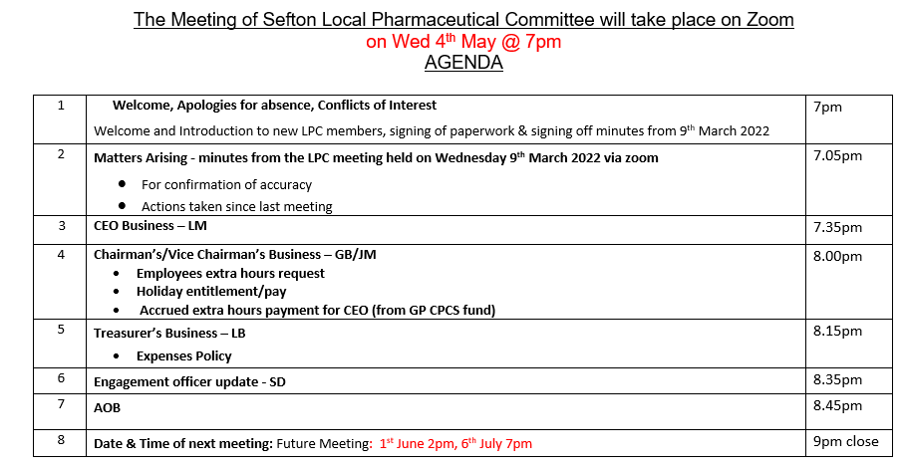

Members | Jan | Feb | Mar | April | May | June | July | Sept | Oct | Nov | Dec | Attend
TM | / | / | / | LPC Meeting Cancelled | / |  |  |  |  |  |  | 4/4 100%
JM | / | / | / |  | / |  |  |  |  |  |  | 4/4 100%
JO | X | / | / |  | / |  |  |  |  |  |  | 3/4 75%
UH | X | / | X |  | / |  |  |  |  |  |  | 2/4 50%
MSt | / | / | / |  | X |  |  |  |  |  |  | 3/4 75%
LB | / | / | / |  | / |  |  |  |  |  |  | 4/4 100%
MSa | / | / | / |  | X |  |  |  |  |  |  | 3/4 75%
DH | / | / | / |  | X |  |  |  |  |  |  | 3/4 75%
ES | / | / | X |  | / |  |  |  |  |  |  | 3/4 75%
Total | 8/9 | 9/9 | 7/9 |  | 6/9

Chair Signature: Date:

1 | Welcome, Apologies for absence, Expressions of Interest | Action
1.1 | Today’s meeting was a remote meeting via Zoom and started at 7:04pm. No conflicts of interest were declared. The previous minutes were signed off as a due and accurate record. JC to add the previous minutes to the website. MSt, MSa & DH sent their apologies. | Action - JC
2 | Matters Arising – minutes from the last LPC meeting
2.1  2.2  2.3  2.4  2.5  2.6  2.7 | LPC Magazine – JC shared that he had extended the LPC magazine from 4 pages to 6 pages. The magazine is complete, apart from the front cover. JC to liaise with both comms subgroup and LM regarding this and complete the magazine. JC to send to the whole committee for approval as soon as ready for publishing. Members to offer final feedback on any potential changes before publishing.  Explore mental health service, linking with PCN. This is an ongoing action from JO. JO requested to leave this action as a reminder to keep chasing on a national level via Lloyds.  JM has sent out invitations to LOC rep but so far has heard nothing back. He will continue to try and link up.  PSNC Finance Review/Expenses Policy - LB discussed briefly but explained that the finance subgroup still need to go through it and combine both policies.  GB was tasked with contacting Ian Cubbin (PSNC) and inviting him to an LPC meeting. This action is ongoing.  The finance subgroup was asked to go through the proposed Budget for this financial year and discuss the possibility of a levy reduction. This has not been actioned. LB explained that they finance subgroup need to take the RSG extra funding for PSNC into consideration. LM explained that this action will be a priority before the next LPC meeting.  Comms Subgroup – MP letter. JM declared he has agreed to facilitate a pharmacy visit with Peter Dowd MP. JM asked members if they had any issues with MP coming into his branch. Members expressed no objections to this. Comms subgroup to meet and go through LM’s notes before contacting Peter Dowd as a follow up. JM to liaise with Peter Dowd MP regarding the MP visit to his store. | Action – JC  Action – JC  Action - All  Action – JO  Action – JM  Action – LB/Finance Subgroup  Action – GB  Action – Finance Subgroup  Action – Comms Subgroup/JM
3 | CEO Business
3.1  3.2  3.3  3.4  3.5  3.6  3.7  3.8  3.9  3.10  3.11  3.12  3.13  3.14 | Blood Pressure – LM gave members an update of the latest blood pressure referrals, including clinic checks and ABPM data. LM shared that she had been in contact from S&F PCN (Amar) around working with CP and UH asked for his contact details so that she could link up with him with a view to increasing referrals using a standardised process.  Smoking Cessation – Re the NHS advanced service from secondary care, we have 6 Sefton contractors signed up to the service so far. LUFT has sent over 3500 referrals so far and will continue to increase. LM reminded members re checking the smokelyser is the correct one and that their training hasn’t expired. The NCSCT training does take a while.  Re Sefton’s enhanced service with ABL health - lots of contractors still haven’t signed and returned their contracts, we are chasing contractors.  Public Health Campaign – LM shared the data from the latest Public Health Campaign (90%) stating that this was dramatically higher than the last PH campaign. Community Pharmacy Sefton had the highest reporting percentage across Cheshire & Merseyside.  Pharmacy Advice Audit - The PSNC have shared the data from the recent Pharmacy Advice audit https://psnc.org.uk/psncs-work/psnc-briefings-psncs-work/psnc-briefing-013-22-summary-of-the-results-of-psncs-2022-pharmacy-pressures-survey/  Comms on the results have been shared with local MPs  Flu Vaccination training – the dates for Cheshire & Merseyside (and Manchester) have been released and are on our website and social media. TM asked why Pharmacists still have to retrain as they are dealing with injections daily. LM shared that this would have to change on a National front.  ICS – This will form from July. There will be nine early adopter sites nationally, with C&M ICS (includes Sefton) being one of them. LM stated the ICS will take on the delegated responsibility for pharmaceutical services commissioning for pharmacy. Many of the NHSEI team will move across from the current area team, from July it will be BAU and won’t look any different. Going forward, the four priorities will be:  - Deliver everything that they are currently delivering whilst transforming  - Recovery, including workforce  - Building systems Integration,  - The wider determinants of health, incorporating education and health to become part of the remit  C&M ICS receive the funds and they share this to 9 different Places – Sefton is one of them, Liverpool is one etc. Will have some services commissioned across all 9 Places the same and some will vary across the Places.  The current CCG commissioned services will be funded until April 2023 – this has been secured.  GPCPCS – We have received the PCC training offer which is felt is a little too late as we only have two GP’s who are not currently live for GPCPCS. There have been over 1500 referrals within Sefton over the last few months.  RSG – Members have seen the proposals and read the documents; LM discussed main issues affecting the LPC. The three-week voting period starts from 23rd May 2022. There is a regional RSG contractor event 16th May, LM is promoting.  Genomics Training – Proposed training dates are around 8th & 23rd June 2022. Genomics centres around testing. Further comms will be sent out accordingly. LM also recommended the Pfizer Business skills workshops she has organised for all members -promoting a service and service improvement.  Provider Pays Issue- LPC has been notified by NHSEI that some contractors have yet to indicate which provider they are going with which may result in lost CPCS, LM has highlighted this issue via her weekly update  COVID 2022 – Talks around making the LES into a NES (local/national) enhanced service. LM will share ongoing thoughts and comms etc accordingly.  NHSEI – LM had a meeting with Tom Knight- Primary care lead NW region. He is sympathetic with the challenges to community pharmacy. He wants all services to be viable and asked LM what things were like within Sefton. LM will continue to liaise and feedback to members wherever necessary.  EHC Issue – LM will continue to liaise with Lynne Hindle at SSH regarding the EHC claims /invoicing issue. LM shared that contractors would have to submit their claims to SSH directly but will only have to do this once a quarter.  DMS Issue- Discussed LM continues to rise the issue of the claiming administration burden. Also concerns around lack of claiming even when the contractors have completed the service. JC to liaise with Tom from Liverpool to look at this data and chase contractors. | Action - UH  Action - JC
4 | Chairman’s Business
4.1 | All of the Chairman’s business took place in a closed meeting to discuss staff working hours, accrued hours, pay increases and extra hours etc. All feedback will be given to Officer’s individually after the meeting today.
5 | Treasurers Business
5.1 | The Treasurer’s business was covered in today’s meeting.
6 | Engagement Officer update
6.1 | SD had no further business to share.
7 | AOB
7.1  7.2  7.3 | LB shared that she logged on to the OCMS training but was the only member there so the meeting was cancelled. LB shared that the subsequent meeting was cancelled too and asked if there were any other OCMS meetings planned. SD said she had the details for this and would forward to LB.  UH shared that PCN’s and Pharmacy could work more cohesively to ensure that PCN’s could see patients face to face by hiring out consultation rooms etc  JC shared the members engagement spreadsheet | Action - SD
8 | Date and time of next meeting
8.1 | The next LPC meeting was changed to Wednesday 8th June 2022 at 2pm. (Changed due to the BH weekend), 6th July at 7pm

Action Log: Highlighted actions are carried over from previous meeting
Min | Action | Person | Update
1.1 | Add minutes to the website | JC | Ongoing
2.1 | Look at getting sponsorship for the CP Sefton Magazine | JC | Ongoing
2.1 | Liaise with comms subgroup and LM regarding front cover | JC
2.1 | Share finalised magazine with members for final approval | JC
2.1 | Offer thoughts on approval for printing for magazine | ALL
2.2 | Explore the possibility of a mental health service via a PCN – JO to send through Lloyds mental health campaign documents for consideration if and when any become available | JO | Ongoing
2.3 | Liaise with LOC rep – Awaiting a response | JM | Ongoing
2.4 | Finance subgroup to review expenses policy | Finance subgroup | Ongoing
2.5 | Liaise with Ian Cubbin regarding attendance to future LPC meeting – Awaiting response | GB | Ongoing
2.6 | Go through proposed budget for 2022/23, taking into consideration the new RSG/PSNC increases | Finance subgroup
2.7 | Communication subgroup - will pick up MP letter/response to Peter Dowd MP  JM to facilitate pharmacy visit | Comms subgroup/JM
3.1 | UH to contact S&F PCN re BP referrals | UH
3.14 | JC to liaise with Tom from Liverpool to look at DMS data and chase contractors | JC | Ongoing
7.1 | Send through details for OCMS training to LB | SD

