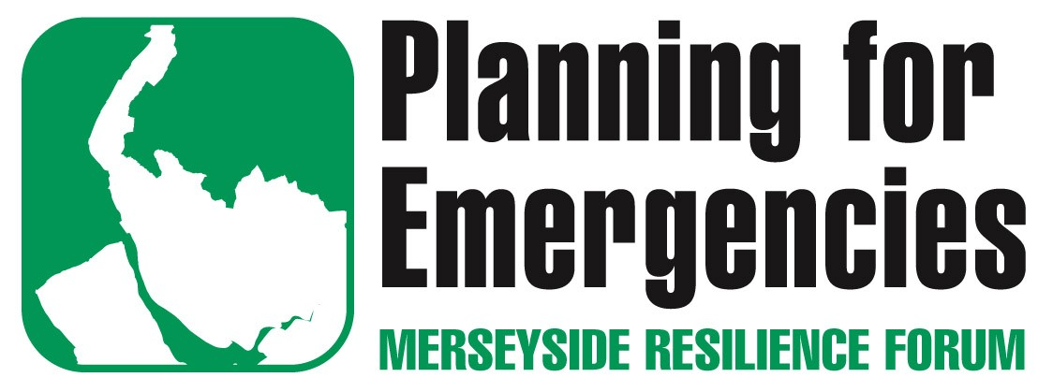

Can’t get out to pick up your medicines due to the current Government advice on Covid-19 (corona virus)?

- GP practices are normally closed on bank holidays, but this year all practices will be open as usual on the Easter bank holidays – Good Friday (10th April) and Easter Monday (13th April).
- If have a prescription request and are unable to collect this personally please can we ask in the first instance that you arrange for this to be collected on your behalf by a family member, friend or neighbour; or if this is not an option delivered to you directly by your pharmacy (if that service is available). This will assist us with the large quantity of requests that we are anticipating.
- Over the Easter bank holiday pharmacies will also be open additional hours on Good Friday and Bank Holiday Monday. People should contact their usual pharmacy directly to check on their exact opening times.
For more information about local pharmacies go to the NHS website https://www.nhs.uk/using-the-nhs/nhs-services/pharmacies/
- In some cases none of the above options may be available to you. In that instance please call your local call centre when your prescription is ready to collect. Please have your pharmacy details to hand when making this call.
- Call Centres:
Liverpool: 0151 233 3066
St Helens: 01744 676767
Sefton: 0345 140 0845
Wirral: 0151 666 5050
Knowsley: 0800 073 0043
Halton: 0303 333 4300
Warrington: 01925 443322

